Name : NC – Saad Masood

Course : BESE – 16A

Subject : Numerical Analysis

Lab Report : 5

Submit to : Sir Kabeer

Example of Lagrange interpolating polynomial

**f(x)=x+2/x at point x0=1, x1=2, and x2=2.5**

Solution:

>> syms x

>> f = x+2/x;

>> X = [1 2 2.5];

>>Y = subs(f,X);

>> L(1,:) = poly([X(2) X(3)])/((X(1)-X(2))*(X(1)-X(3))

L= 0.6667 -3.0000 3.3333

>> L(2,:) = poly([X(1) X(3)])/((X(2)-X(1))*(X(2)-X(3))

L= 0.6667 -3.0000 3.3333

-2.0000 7.0000 -5.0000

>> L(3,:) = poly([X(1) X(2)])/((X(3)-X(1))*(X(3)-X(2))

L= 0.6667 -3.0000 3.3333

-2.0000 7.0000 -5.0000

1.3333 -4.0000 2.6667

>> P = Y(1)*L(1,:) + Y(2)*L(2,:) + Y(3)*L(3,:);

P=0.4000 -1.2000 3.8000

>> pretty(poly2sym(P))

2

2 x 6 x

---- - --- + 19/5

5 5

Exercise 1

**Verify above coefficient for the x=1 , x=1.2, x=1.7**

Solution:

1. x=1

>> polyval(P,1)

ans =3.0000

>>1+2/1

ans =3

1. x = 1.2

>> polyval(P,1.2)

ans =2.9360

>> 1.2+2/1.2

ans =2.8667

1. x = 1.7

>> polyval(P,1.7)

ans =2.9160

>> 1.7+2/1.7

ans =2.8765

Exercise 2

**Calculate the third degree Lagrange polynomial for f(x)=cos(x). X=[0.0 0.4 0.8 1.2] Verify output for two different value of x and also plot the graph for comparison.**

Solution:

>> syms x

>> f = cos(x)

>> X = [0.0 0.4 0.8 1.2];

>> Y = subs(f,X)

Y = 1.0000 0.9211 0.6967 0.3624

>> L(1,:) = poly([X(2) X(3) X(4)])/((X(1)-X(2))*(X(1)-X(3))*(X(1)-X(4)))

L = -2.6042 6.2500 -4.5833 1.0000

>> L(2,:) = poly([X(1) X(3) X(4)])/((X(2)-X(1))*(X(2)-X(3))*(X(2)-X(4)))

L = -2.6042 6.2500 -4.5833 1.0000

7.8125 -15.6250 7.5000 0

>> L(3,:) = poly([X(1) X(2) X(4)])/((X(3)-X(1))*(X(3)-X(2))*(X(3)-X(4)))

L = -2.6042 6.2500 -4.5833 1.0000

7.8125 -15.6250 7.5000 0

-7.8125 12.5000 -3.7500 0

>> L(4,:) = poly([X(1) X(2) X(3)])/((X(4)-X(1))*(X(4)-X(2))*(X(4)-X(3)))

L = -2.6042 6.2500 -4.5833 1.0000

7.8125 -15.6250 7.5000 0

-7.8125 12.5000 -3.7500 0

2.6042 -3.1250 0.8333 0

>> P = Y(1)*L(1,:) + Y(2)*L(2,:) + Y(3)*L(3,:) + Y(4)*L(4,:)

P = 0.0922 -0.5651 0.0139 1.0000

>> poly2sym(P)

ans = (103854322258387*x^3)/1125899906842624 - (2545038855530473*x^2)/4503599627370496 + (62774580982811*x)/4503599627370496 + 1

>>ee = ans

%**verification:**

**%for x=1**

>> polyval(P,1)

ans = 0.5411

>> cos(1)

ans = 0.5403

**%for x=0**

>> polyval(P,0)

ans =1

>> cos(0)

ans =1

**%plot Graph:**

>> h1=ezplot('cos(x)',0,2)

h1 = 180.0023

>> hold on

>> h2 = ezplot(ee,0,2)

h2 = 182.0023

>> set(h2,'color','m')

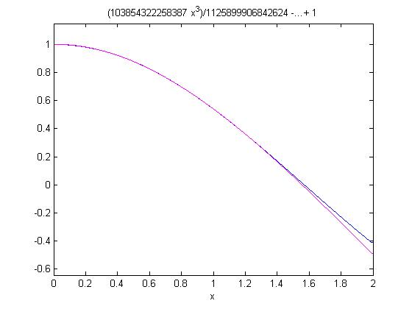

Pink line shows lagrange equation graph, and blue shows true function graph.

Exercise 3

**Calculate interpolation polynomial for given point X= [0:5] and function f(x) =1.5x cos(2x),by using Lagrange polynomial. Make a figure for Lagrange polynomial. In this figure show the points, a plot of function, and curve that corresponds to this method.**

Solution:

%Make a function name lagran, it has two argument and two return types.

function [C,L]=lagran(X,Y)

%Input - X is a vector that contains a list of abscissas

% - Y is a vector that contains a list of ordinates

%Output - C is a matrix that contains the coefficents of

% the Lagrange interpolatory polynomial

% - L is a matrix that contains the Lagrange

% coefficient polynomials

w=length(X);

n=w-1;

L=zeros(w,w);

for k=1:n+1 %Form the Lagrange coefficient polynomials

V=1;

for j=1:n+1

if k~=j

V=conv(V,poly(X(j)))/(X(k)-X(j));

end

end

L(k,:)=V;

end

%Determine the coefficients of the Lagrange interpolator

%polynomial

C=Y*L;

**>> X= [0:5]**

X = 0 1 2 3 4 5

**>> Y =(1.5.^X).*(cos(2.*X))**

Y = 1.0000 -0.6242 -1.4707 3.2406 -0.7366 -6.3717

**>> [P L] = lagran(X,Y)**

P = 0.3359 -4.1513 17.3082 -27.5143 12.3974 1.0000

L =

-0.0083 0.1250 -0.7083 1.8750 -2.2833 1.0000

0.0417 -0.5833 2.9583 -6.4167 5.0000 0

-0.0833 1.0833 -4.9167 8.9167 -5.0000 0

0.0833 -1.0000 4.0833 -6.5000 3.3333 0

-0.0417 0.4583 -1.7083 2.5417 -1.2500 0

0.0083 -0.0833 0.2917 -0.4167 0.2000 0

**%Plot:**

>> ezplot(poly2sym(Y))

>> hold on

>> h1 = ezplot(poly2sym(P));

>> set (h1,'color','g')

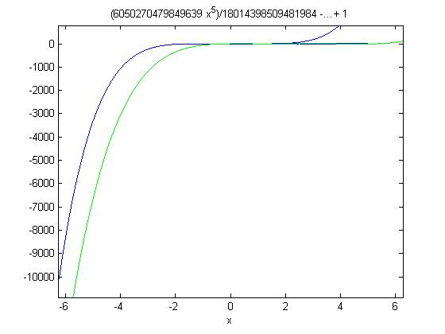

The blue line shows original function graph and green line shows lagrange polynomial graph.

Exercise 4

**Write the Matlab function with name lagran to compute the generalized Lagrange coefficient and also display the graph of comparison.**

Solution:

%Make a function name lagran, it has two argument and two return types.

function [C,L]=lagran(X,Y)

%Input - X is a vector that contains a list of abscissas

% - Y is a vector that contains a list of ordinates

%Output - C is a matrix that contains the coefficents of

% the Lagrange interpolatory polynomial

% - L is a matrix that contains the Lagrange

% coefficient polynomials

w=length(X);

n=w-1;

L=zeros(w,w);

for k=1:n+1 %Form the Lagrange coefficient polynomials

V=1;

for j=1:n+1

if k~=j

V=conv(V,poly(X(j)))/(X(k)-X(j));

end

end

L(k,:)=V;

end

%Determine the coefficients of the Lagrange interpolator

%polynomial

C=Y*L;